Codev Setup Instructions



**V3locity AZPSPRS CoDev Instructions**

1. Accessing Workspace

Vitech Inc.

2. Accessing Instances

3. DB Client

3.1 DB Instance Details

3.2 DBeaver

Setup DB Connection

4. GitHub Access

5. Checkout, Build and Run

5.1 Checkout Code from GitHub

5.2 Build

5.3 Setup IDE

Setup Eclipse

Verify Java Version

Import Project

Create Run/ Debug Configuration

5.4 Run V3locity

Access the Local Instance

1. Accessing Workspace

Install AWS Client

Run the AWS Client Application

Login using the vitechb2c account username and password

(username@vitechb2c.com)

2. Accessing Instances

Open URL [https://azpsprsdev.v3locitydev.com/app into](https://azpsprsdev.v3locitydev.com/app) a chrome browser window to access the Dev instance.

3. DB Client

3.1 DB Instance Details

**Sr Environment Server Url DB Name**

1 Dev [azpsprsdev-cluster.cluster-ctcsve9jprsn.us-east-1.rds.amazonaws.com azpsprsdev](http://azpsprsdev-cluster.cluster-ctcsve9jprsn.us-east-1.rds.amazonaws.com/)

3.2 DBeaver

**Setup DB Connection**

Select New Database Connection

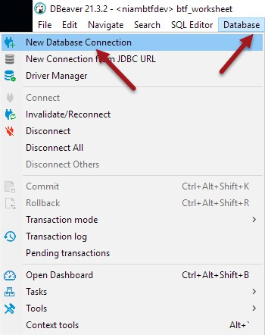

Select PostgreSQL

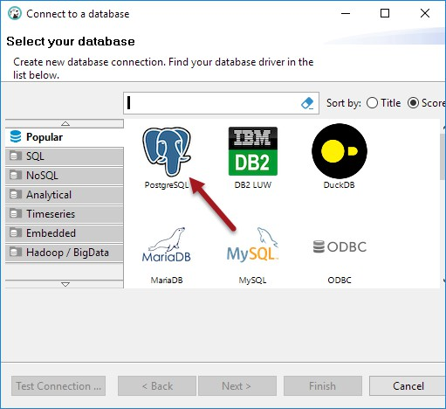

Enter db connection details Host, Database, Username and Password

Test Connection

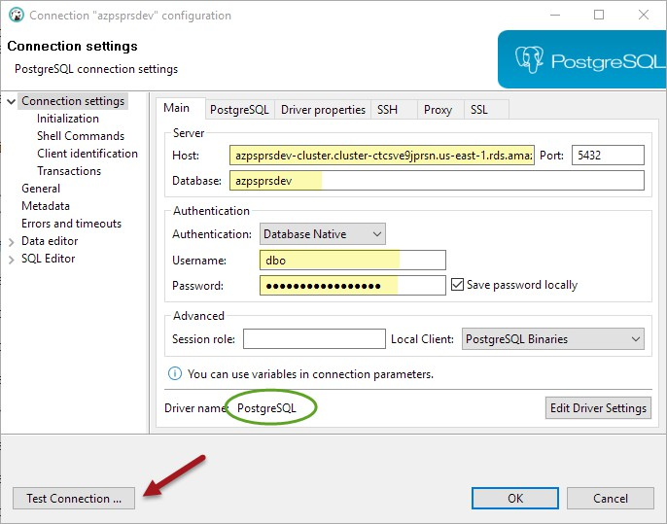



4. GitHub Access

Verify your GitHub Access by opening the SSO url ([https://github.com/enterprises/vitech)](https://github.com/enterprises/vitech) in chrome

If it does not recognize your username (username@vitechb2c.com), then use **<username>_vitech@vitechb2c.com** and then use the vitechb2c password to log on

Once you have verified access in Chrome also make sure Chrome is your **default browser**, as we will use the browser login mode to authenticate to GitHub from the command prompt.

5. Checkout, Build and Run

5.1 Checkout Code from GitHub

Open Git Bash

Navigate to the directory where the code will be checked out (d:\users\<user>\projects\azpsprs)

Run command "git clone ‘url from forked Github’ azpsprs " see image below



Git may take you to chrome for authentication

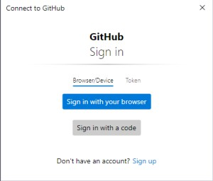

The code will then be checked out into the subdirectory with name **azpsprs**

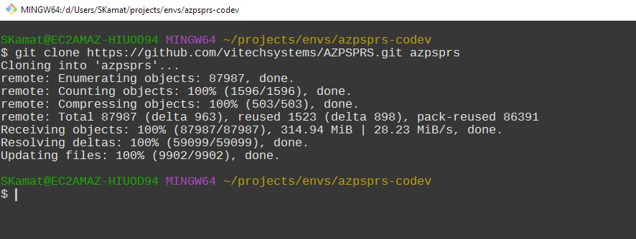

5.2 Build

Open GitBash

Navigate to the folder where the code was checkedout (c:\users\<user>\projects\azpsprs\azpsprs) Verify Maven is installed and the version is **3.8.1**

Run mvn --version to verify

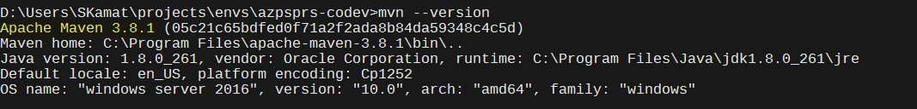

Verify Java is installed and the version is **OpenJDK Corretto 11**

Run java -version to verify

If java version is not 11.0.7 then run the following command in your command shell:

“set JAVA_HOME=C:\Program Files\Java\jdk-11.0.7”

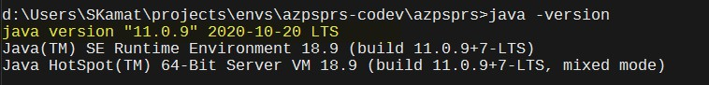

Run the below command

mvn clean install -T4 -Pdev eclipse:clean eclipse:eclipse



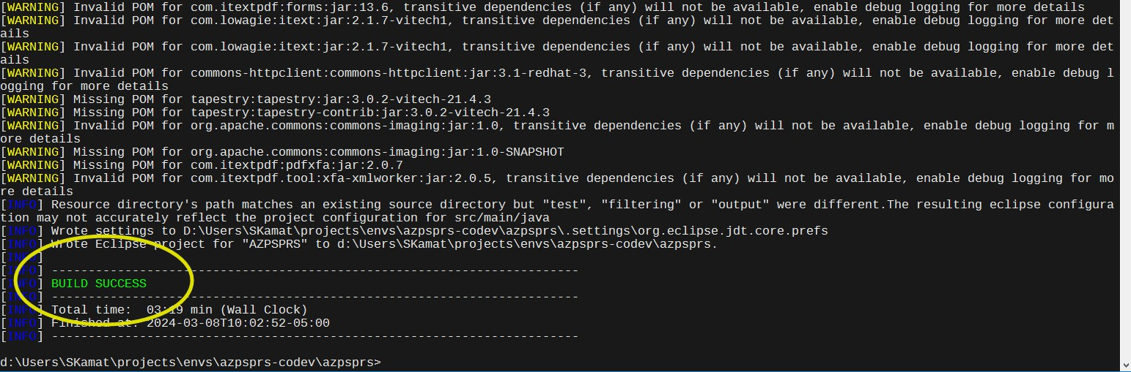

Verify that the build was successful

5.3 Setup IDE

**Setup Eclipse**

Create a new workspace (c:\users\<user>\projects\azpsprs)

This is the directory “above” the code downloaded in previous steps

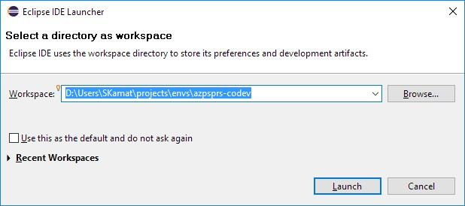

Click Launch

Hide the welcome Screen

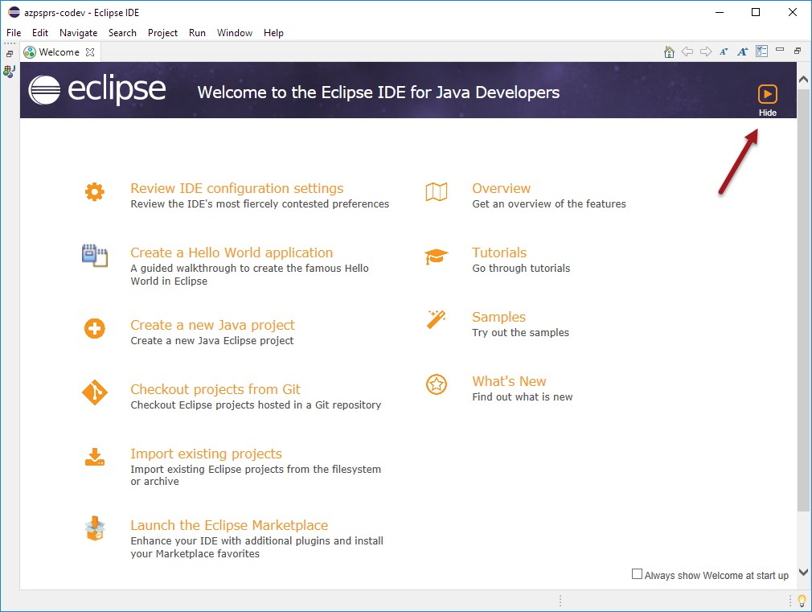

**Verify Java Version**

Go to Window > Preferences

Select Java > Installed JRES

Verify there is a Java 11 JRE available and selected

If jdk-11.0.7 does not show up in the list below of installed JRE’s then click the Search button and select the Java folder like the image below. This should populate a list of JRE’s and the select the jdk-11.0.7 version and hit apply and close button.

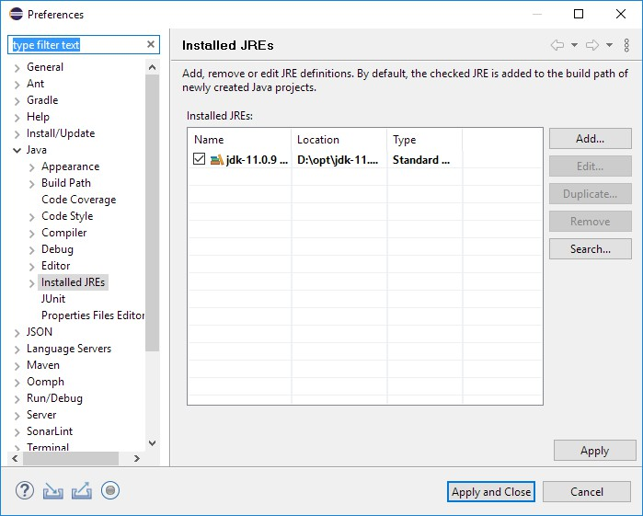

**Import Project**

Go to File > Import...

Select General > Existing Projects into Workspace and Click Next

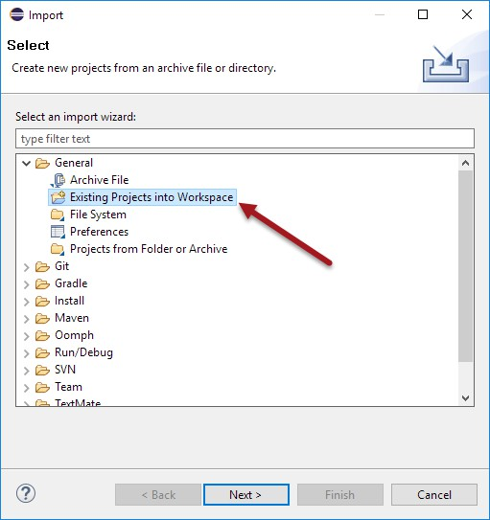

Select Browse and select the folder where the code was checked-out and built and click "Select Folder"

(c:\users\<user>\projects\azpsprs\azpsprs)

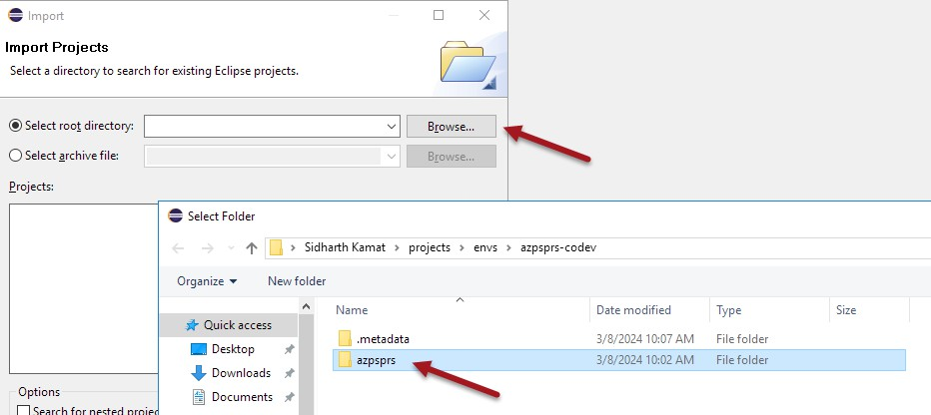

Click Finish to import the project(s)

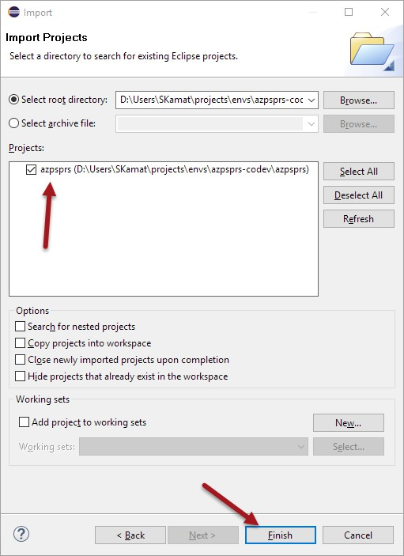

**Create Run/ Debug Configuration**

Name: v3locity

Project: azpsprs

Main Class: com.vitechinc.core.util.Launcher

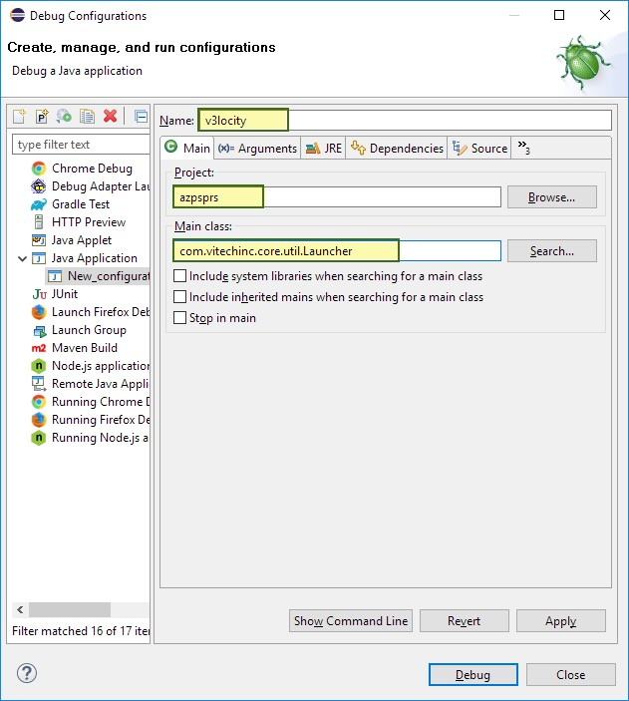

Setup VM Arguments



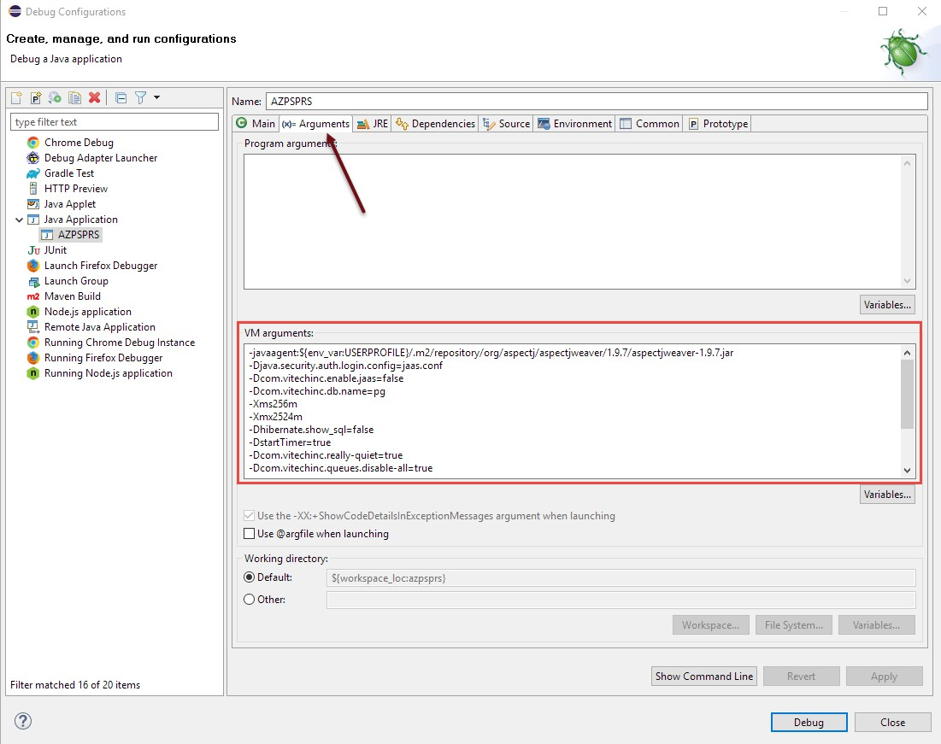

5.4 Run V3locity

Open instance_pg.properties in the root folder and verify that the connection details are pointing to the database instance you want the local instance to connect to

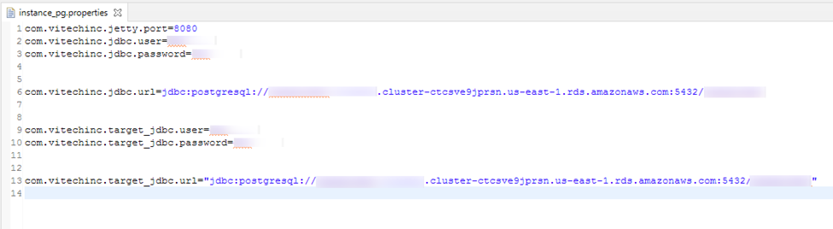

Select the Debug Dropdown and run the configuration we just created

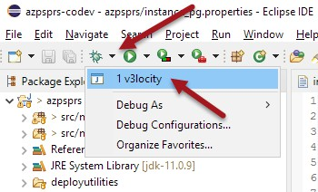

Wait for the local server to start

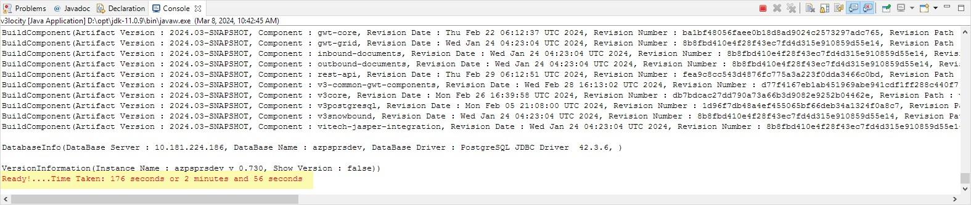

**Access the Local Instance**

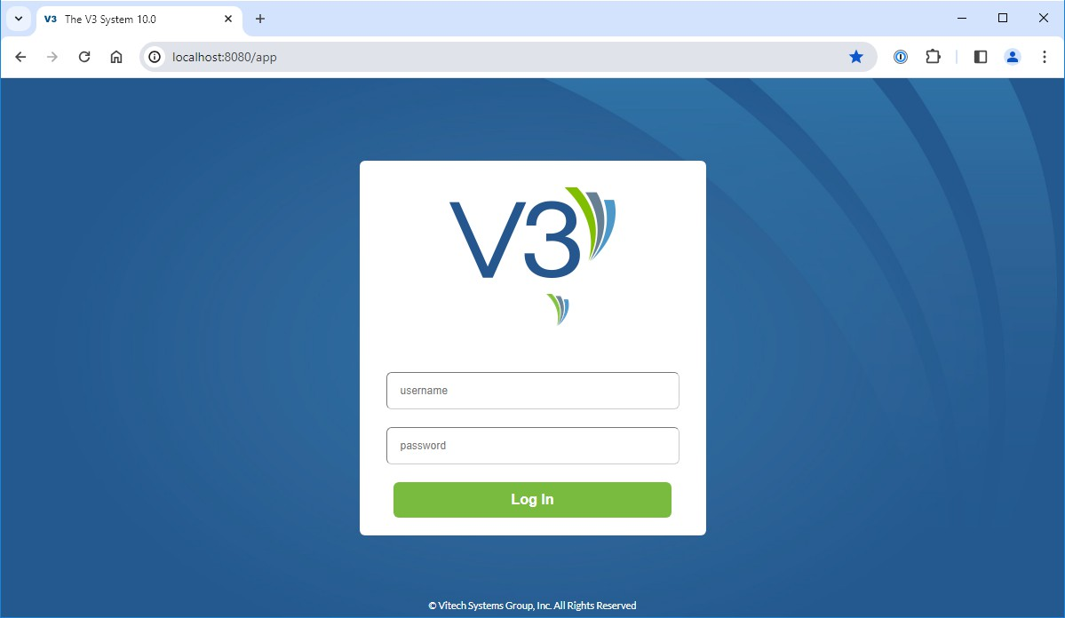

**Congratulations!!** You have a local instance of V3locity running, You can now login with your credentials for the instance this is connected to.